

User Manual

Miguel Stiven Cortes Duarte

Centro Tecnologico De La Amazonia (CTA - SENA)

04/2026

Scope:

This document describes each of the corresponding functionalities of the PharmaQuick system (for the role of Customer or natural user), where each of the modules are contemplated such as: Module to view the catalog, log in, buy products..)

Table of Contents:

1. Introduction: 4
2. Registration in the System: 5
3. Login to the System 7
4. Forgot your password? 9
5. Product Catalog 12
6. Shopping cart. 15
7. My purchases: 25
8. My Profile 29
9. Log out. 31

Introduction:

The PharmaQuick web application (Internal system for pharmacy management and pharmaceutical sales, inventory control, purchase order generation and sending email notifications) is designed to simplify and automate the critical processes of a pharmacy or health point of sale.
With PharmaQuick, warehouse managers, pharmacists and administrative staff can:
- Control the availability and movement of products in real time, avoiding stockouts and facilitating the replenishment of medicines.
- Register and manage sales in an agile way, with automatic generation of invoices and purchase receipts.
- Send automatic notifications (purchase confirmation, welcome emails, password recovery, etc.) using an integrated email solution that includes embedded logos and error handling so that the customer experience is not interrupted.
In short, PharmaQuick centralizes pharmacy management on a single platform, provides complete visibility of stock and transactions, and automates communication with customers and staff, all under a simple and accessible user experience.

Registration in the System:

To register for the PharmaQuick system, after entering the platform we will have 2 ways to do it, one with the button on the upper right side and the other with the one that appears next to the title of the platform as seen below: 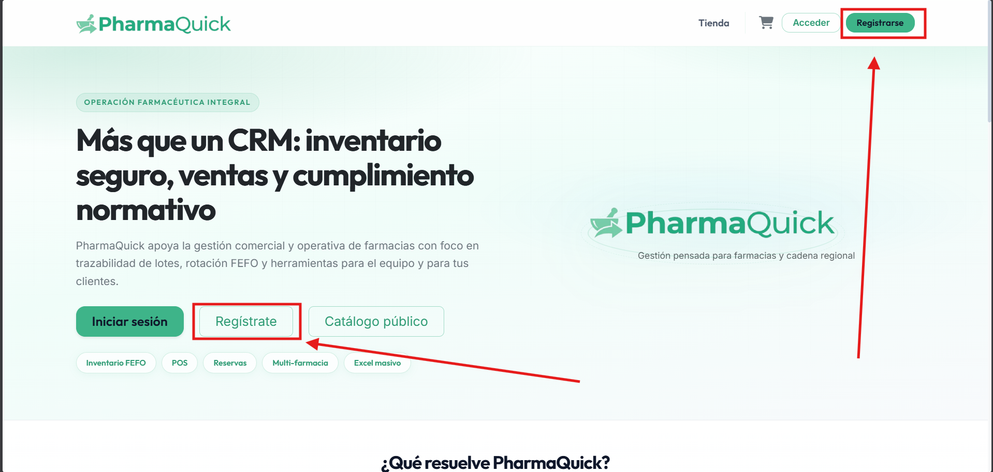

Pressing any of these buttons will open the window:
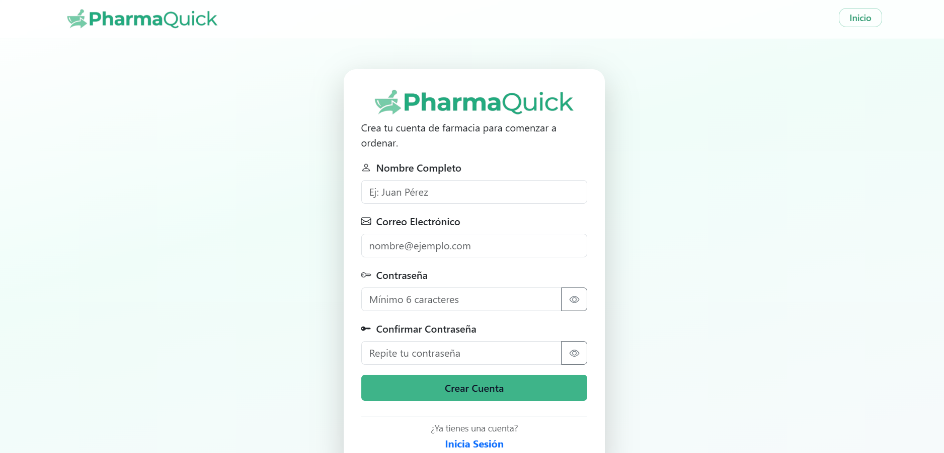

In this window we can enter some basic data such as: "email, username, password." to register on the platform correctly.
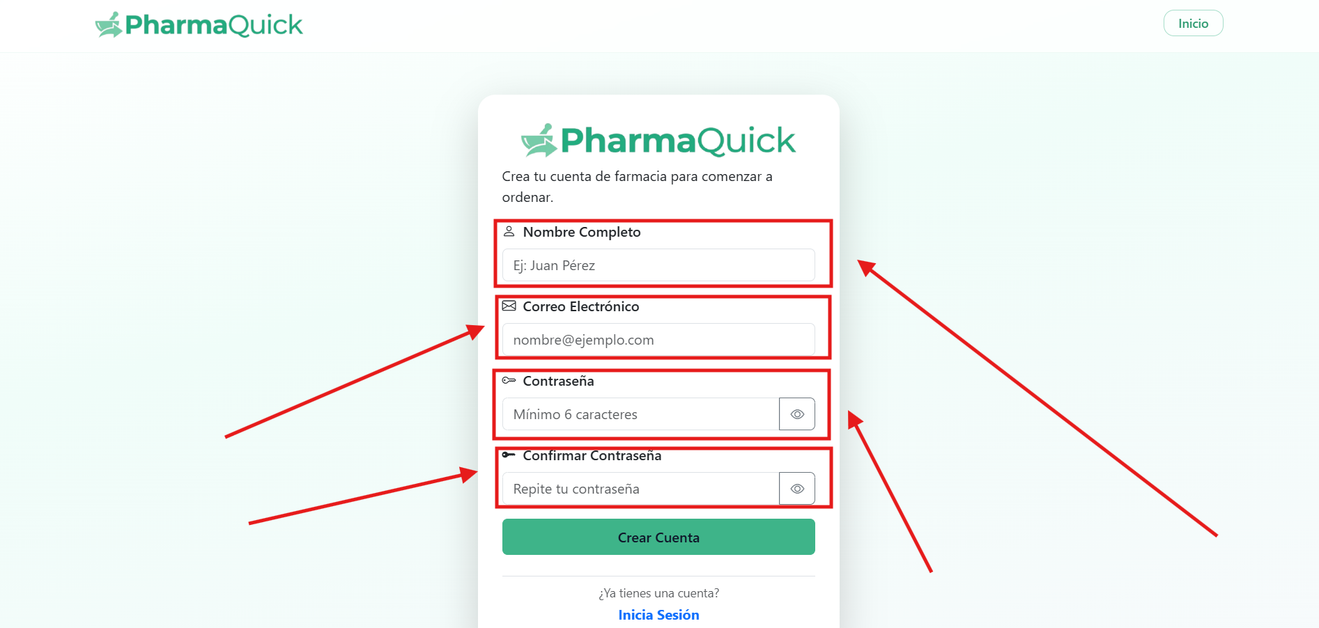

By doing this, if the page lets us create the account correctly, we will be able to see how a confirmation arrives to the email with which we created the account:
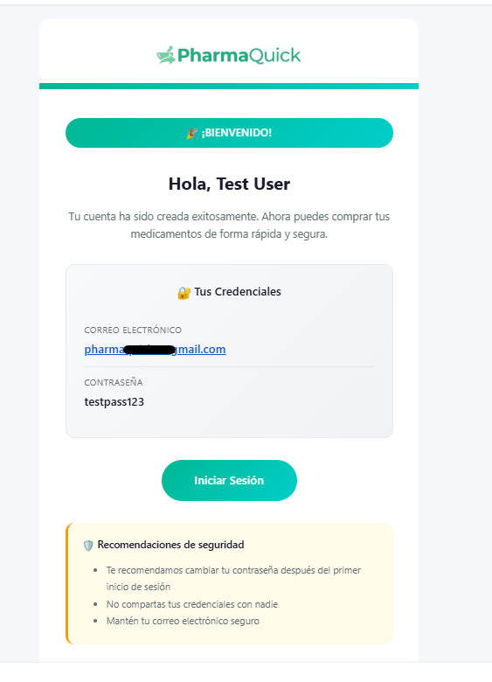

Login to the System

After having registered in the system we can enter the system in two ways from the main page, either with the login button, or the "access" button at the top right:
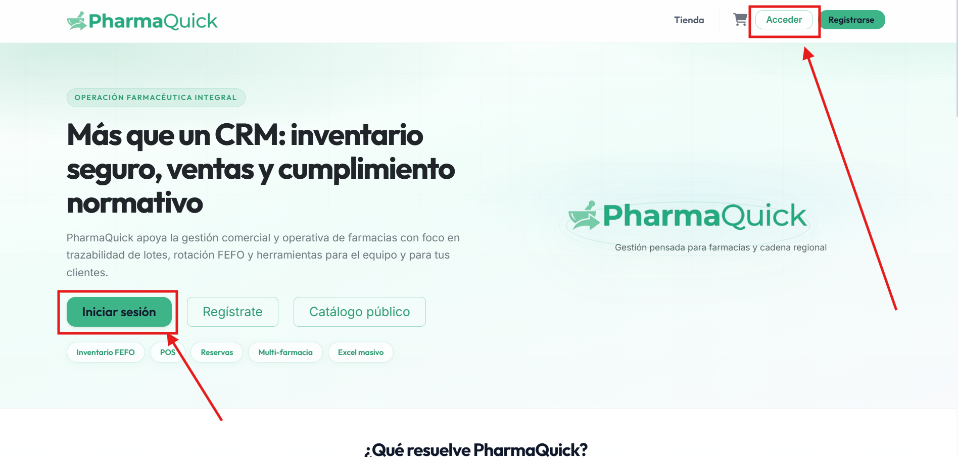

When you log in, you are asked for the email address with which you created the account:
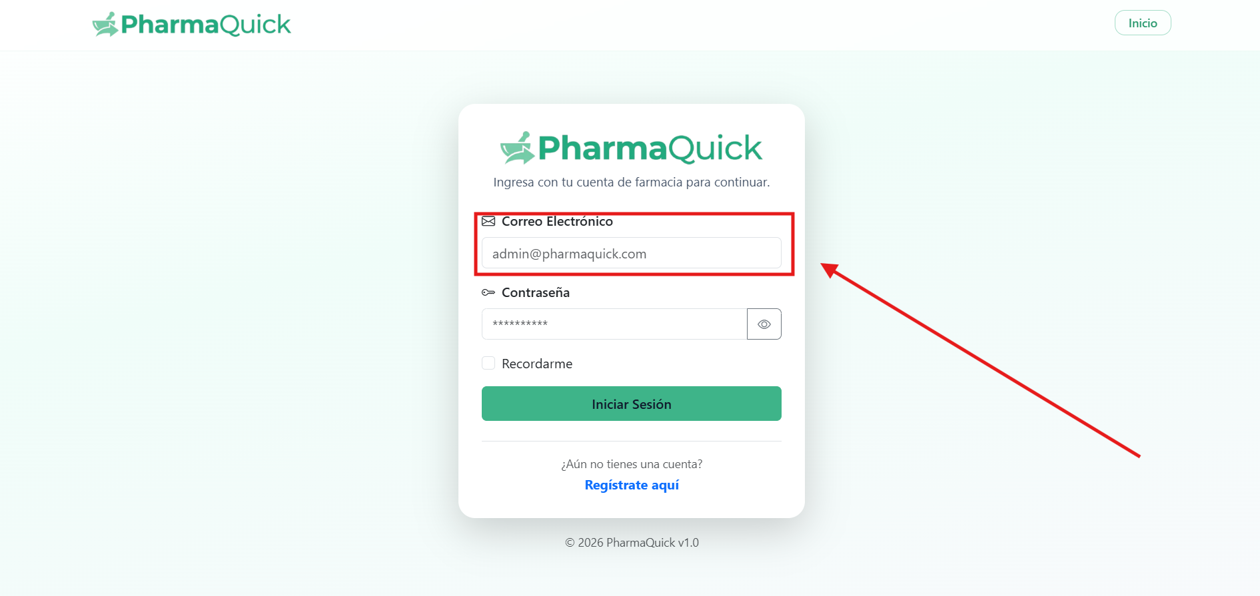

You are also asked to enter the password at:
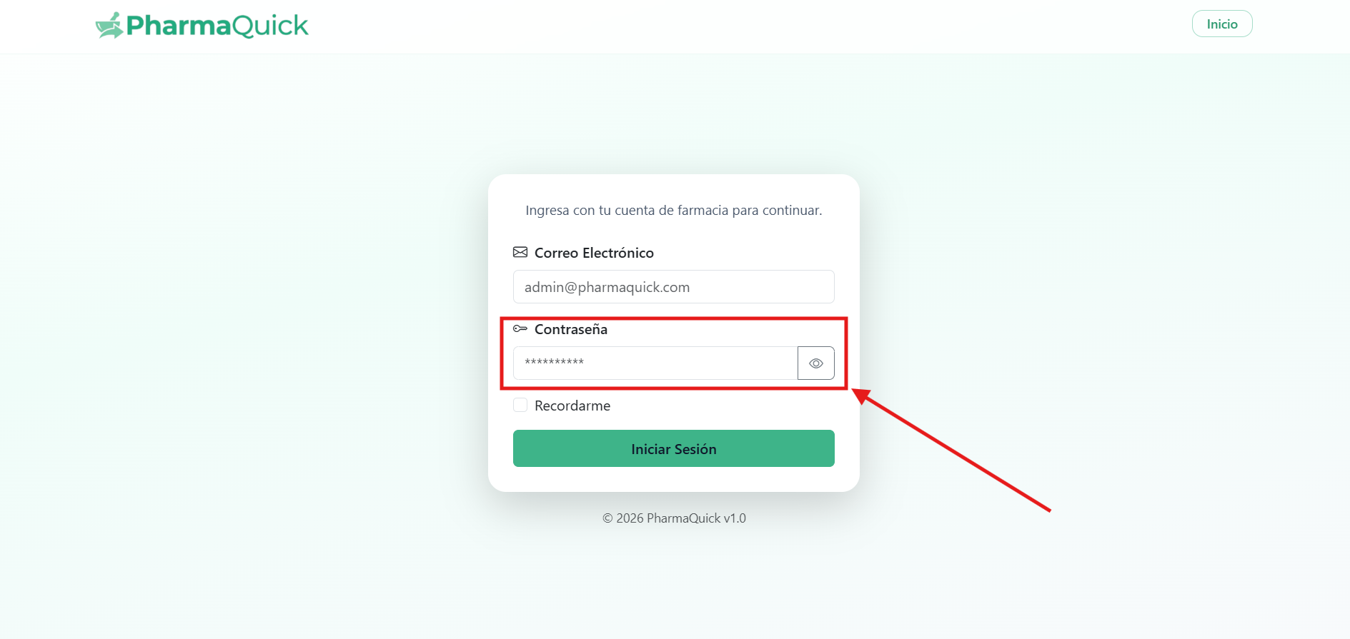

Finally, just use the "login" button
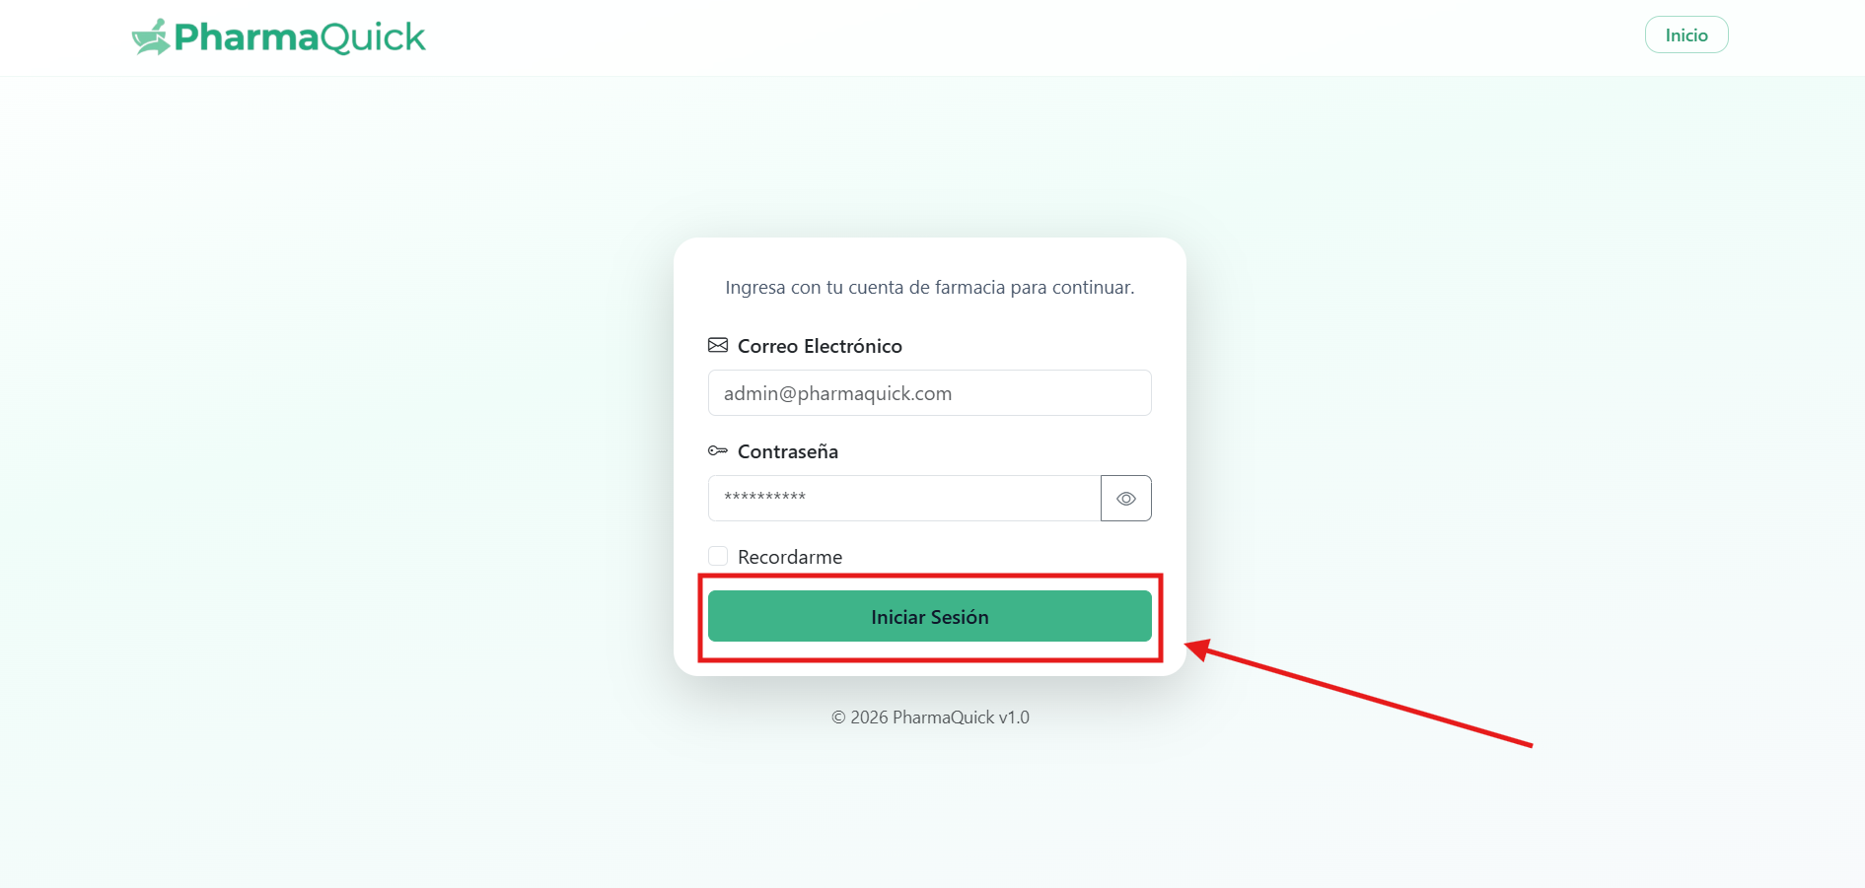

Forgot your password?

We can access this section from the login page by pressing the button: 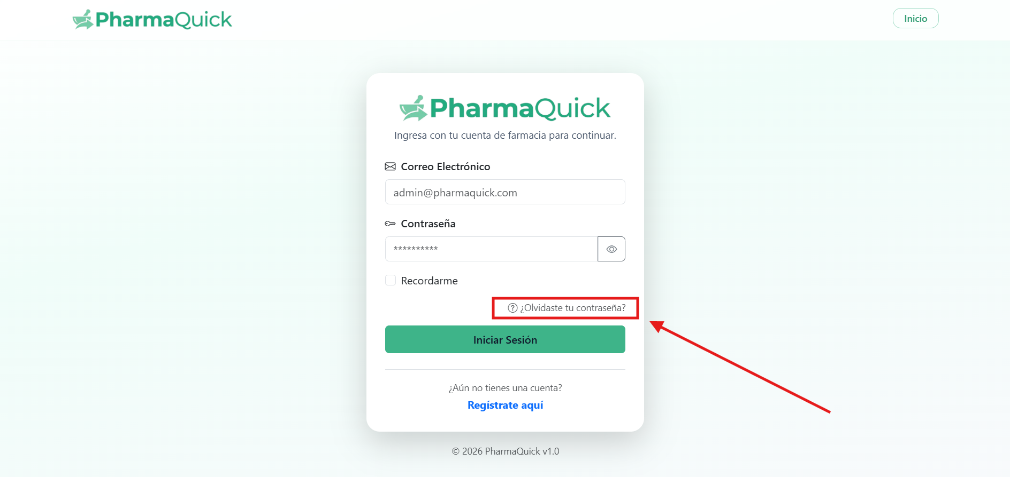

Then we will be asked to write our email in the field:
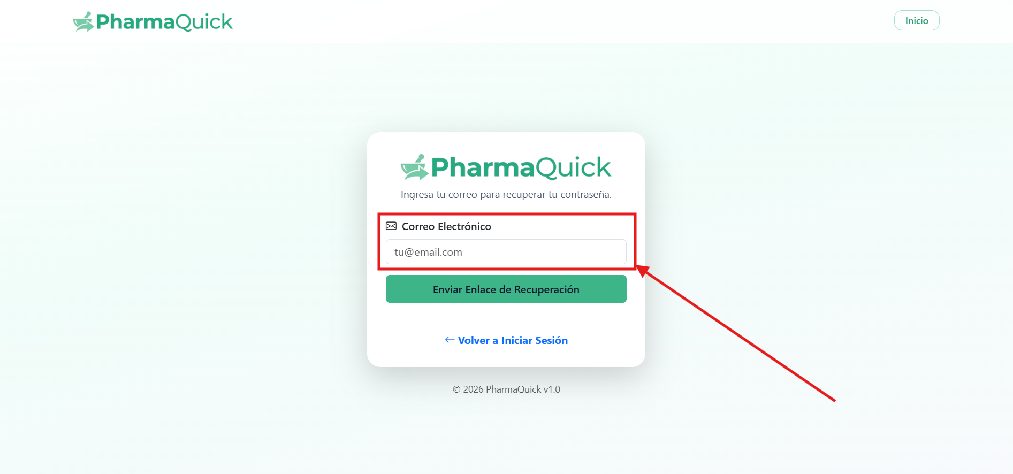

When you enter it, you can send it using the button: 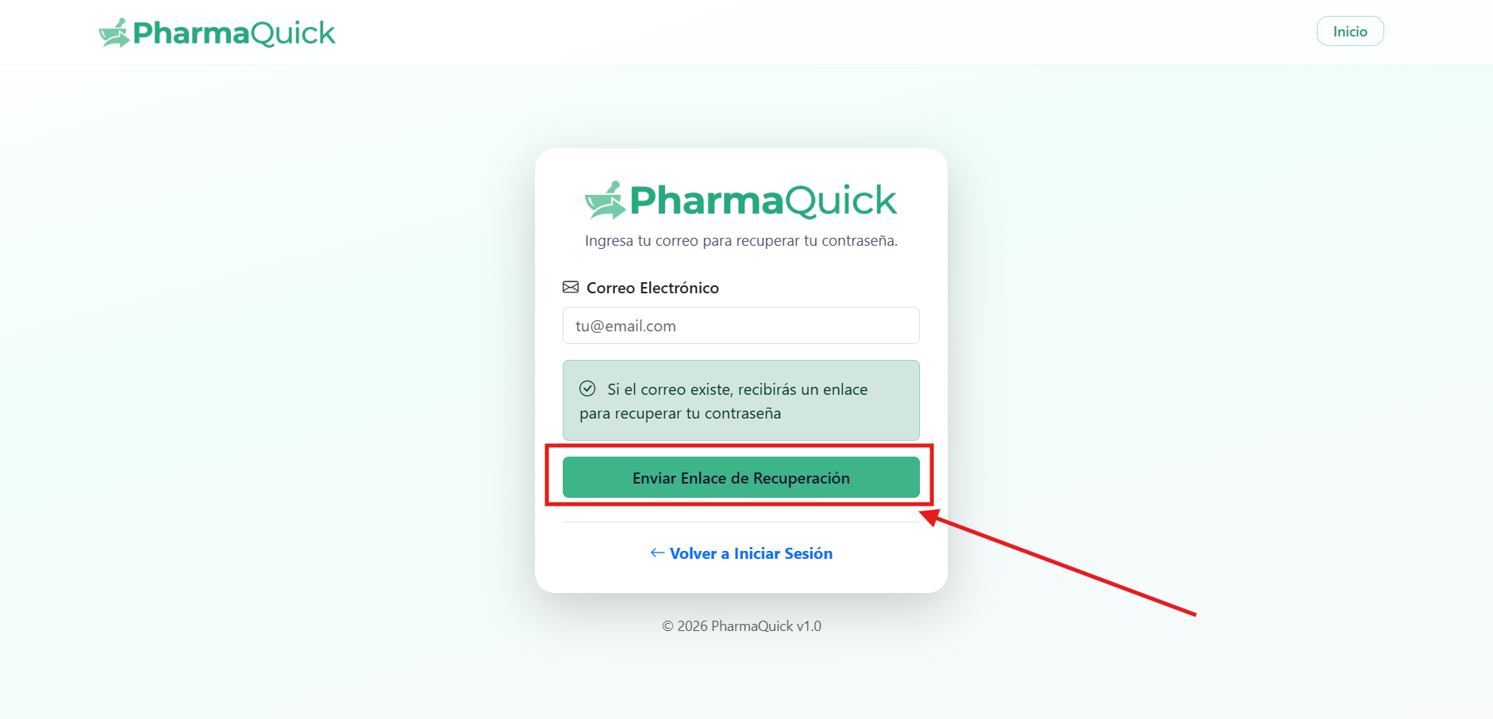
If we did it right, it will reach our email: 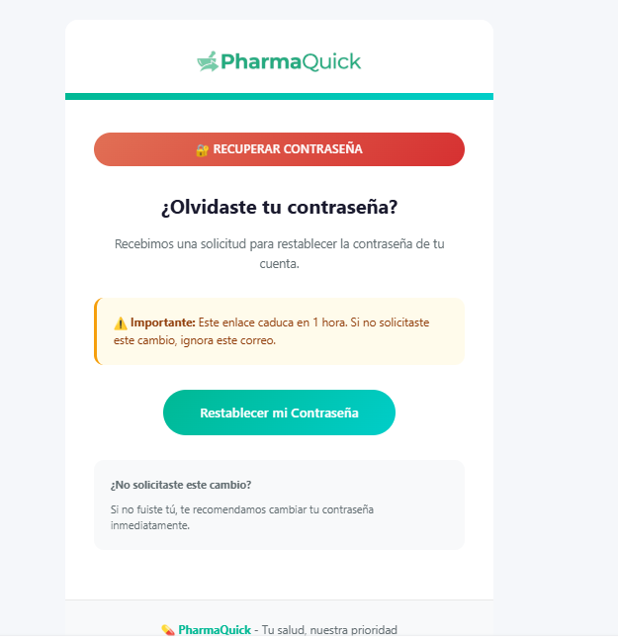
And when you press the reset button, a new page will appear where you must enter the new password:
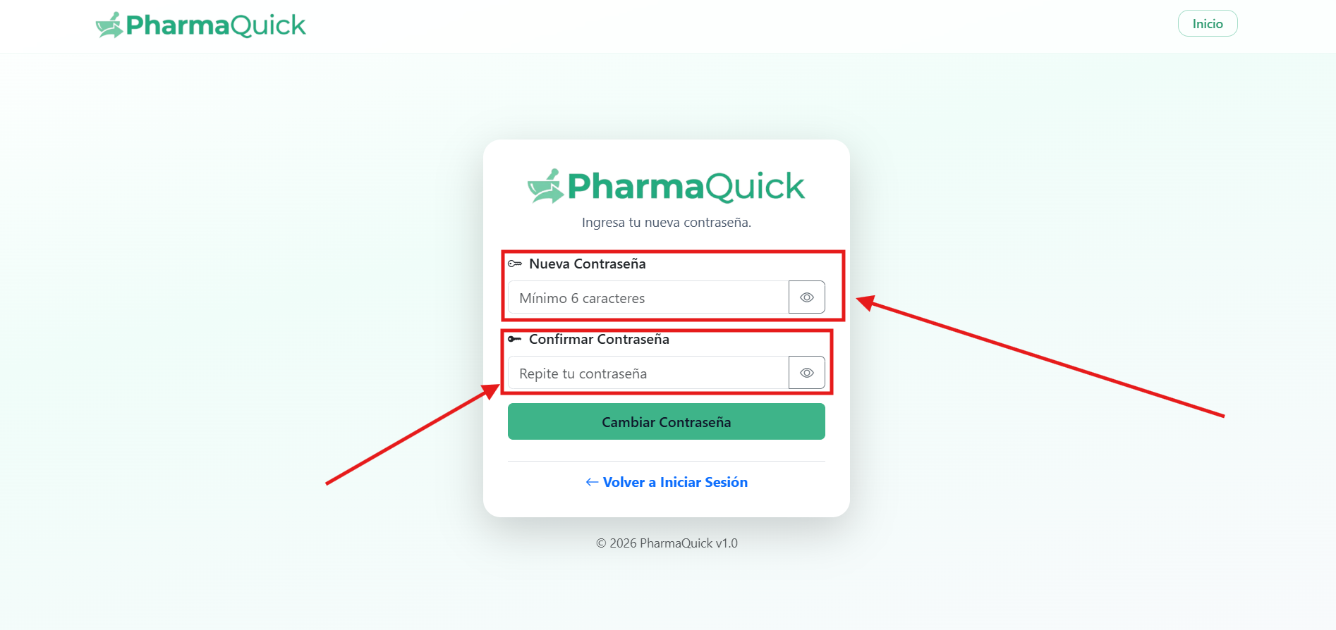
And with this we will be able to recover our password correctly.

Product Catalog

When entering the platform, the first page that is shown to us is the product catalog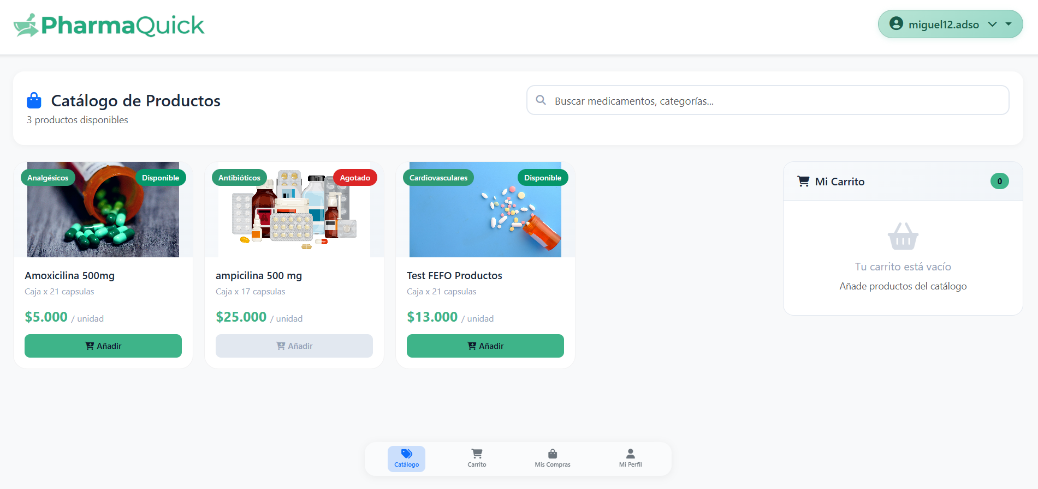
In which we can add objects to the cart by pressing the "add" button on the desired product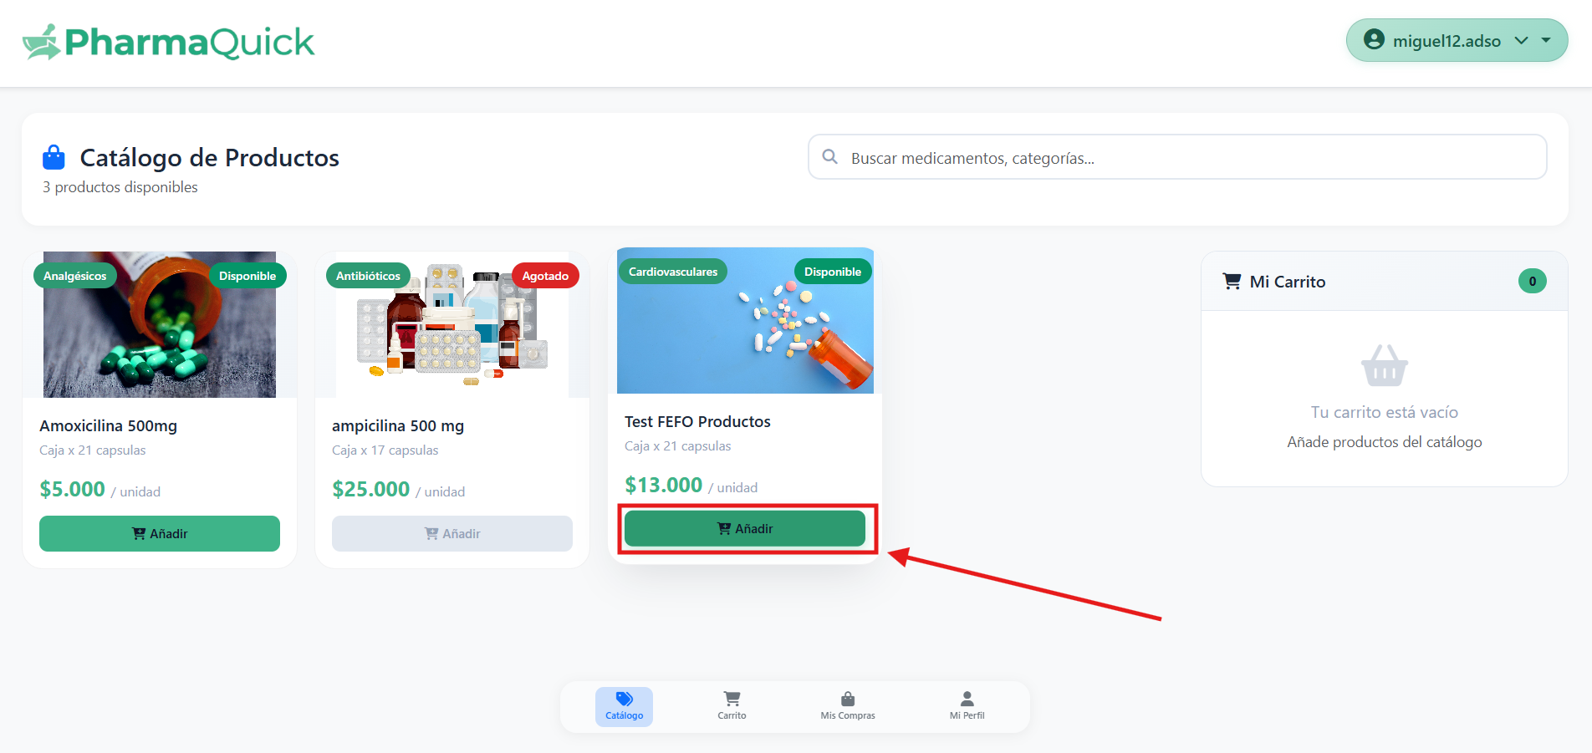
After doing this, on the right side of the screen we will be charged the chosen products that we want to buy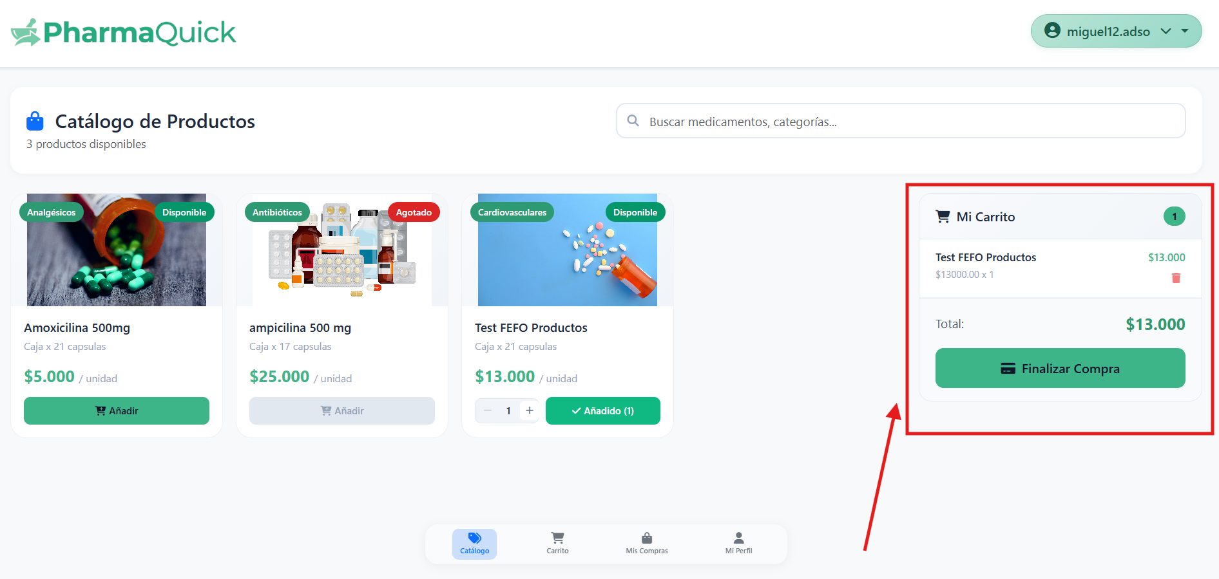

If we press the "Checkout" button 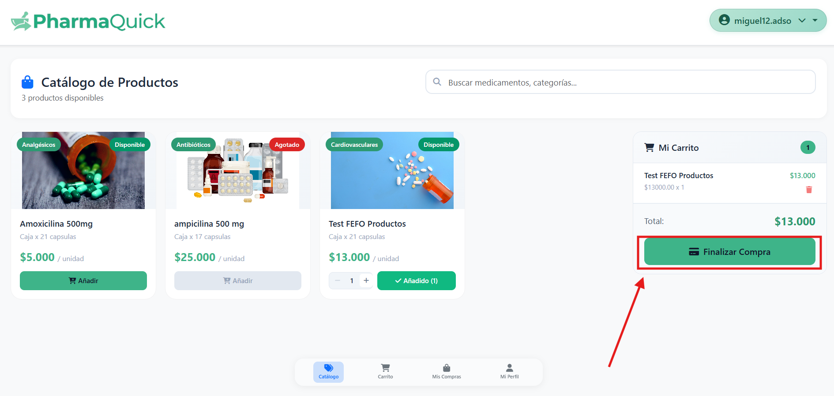
It will take us to another section that we can also enter by clicking on the bottom menu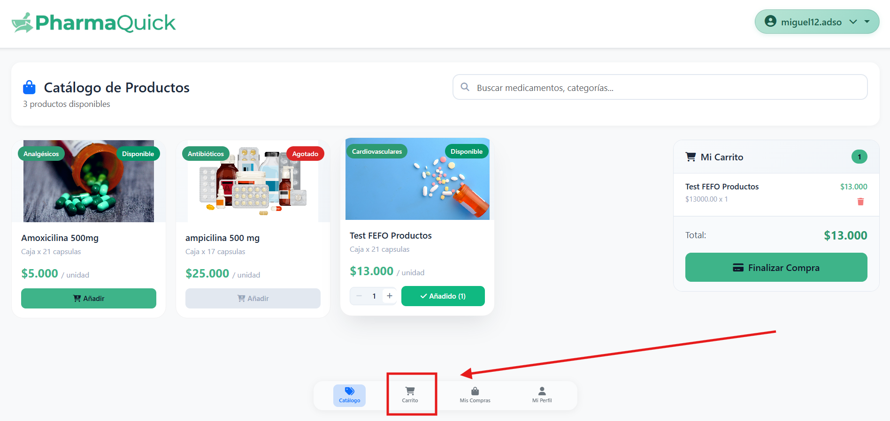

Shopping cart.

When entering this platform from the bottom button 

As long as we have already added a product, the following page will be loaded: 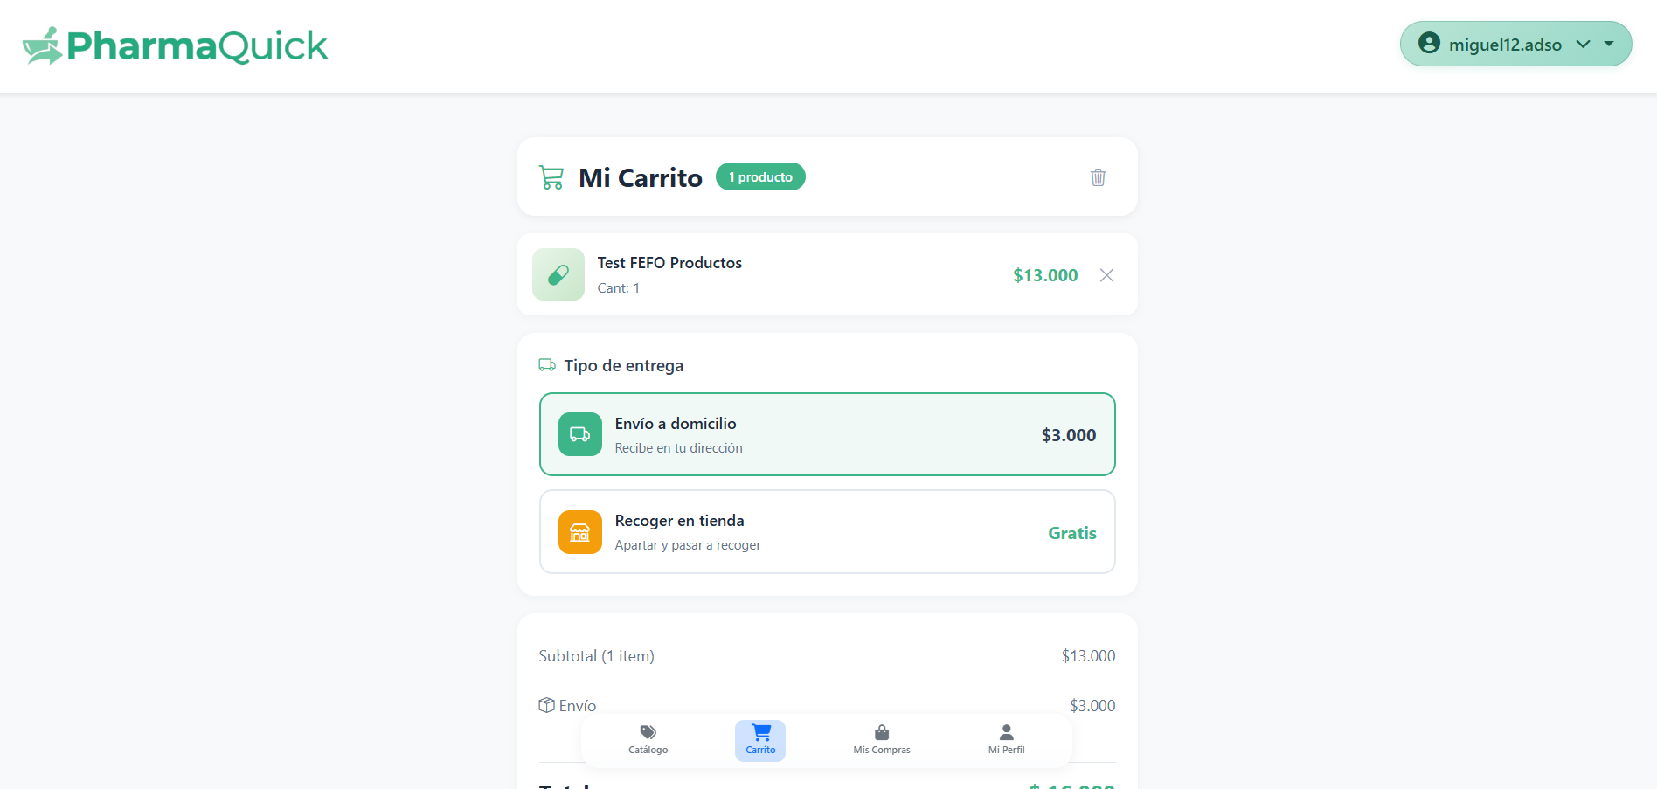
In this we will have 2 options, the first is to receive a home delivery of the product we are going to buy (this option has a cost for delivery): 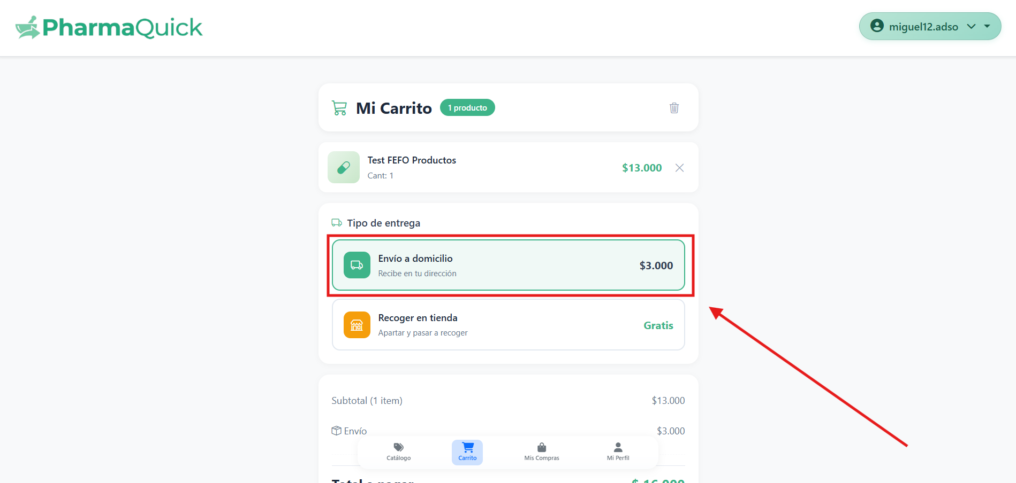

And the second option would be when we want to "set aside" a product by buying it to pick it up at the pharmacy later, selecting: 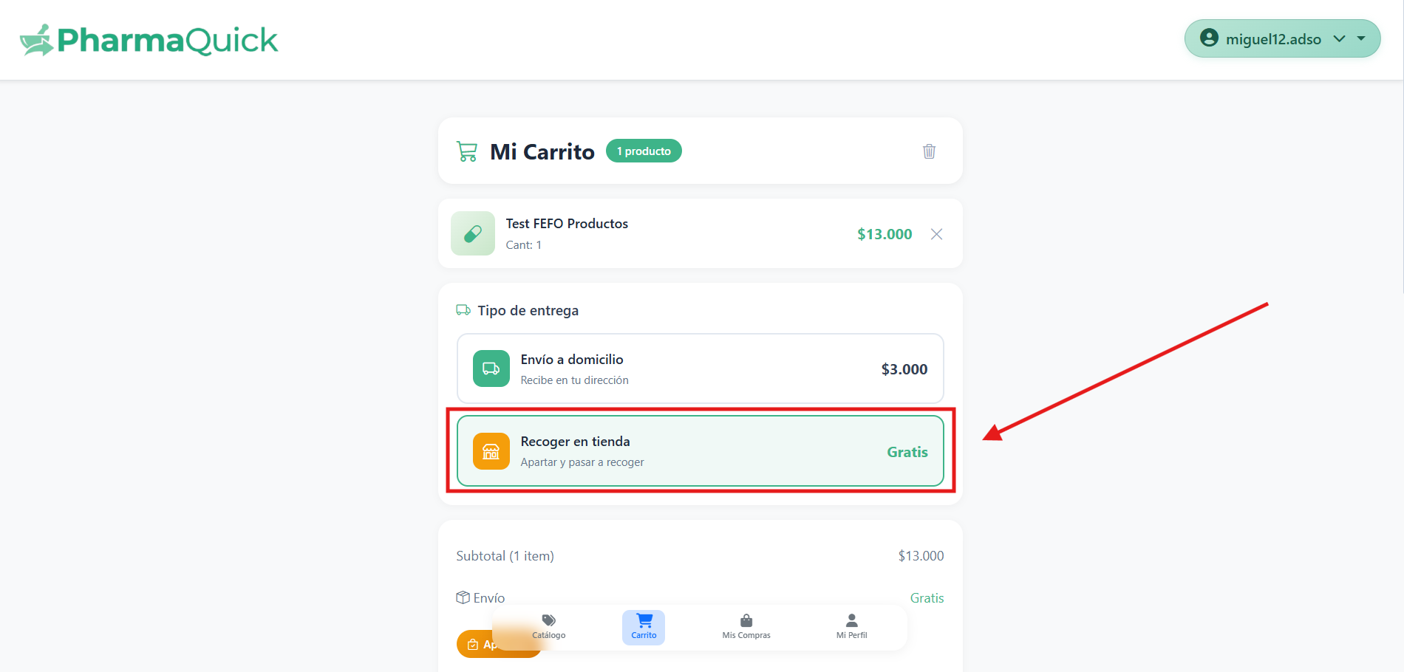

Depending on what we choose, we will be asked for data such as the name of the buyer: 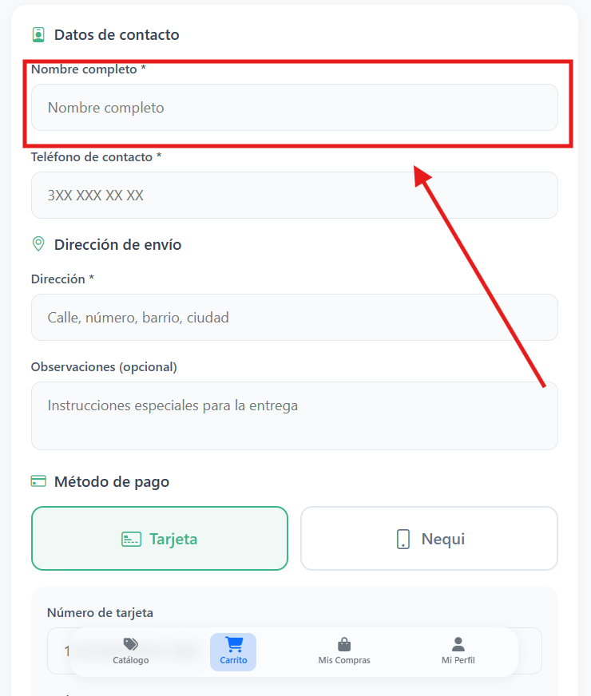

The contact number: 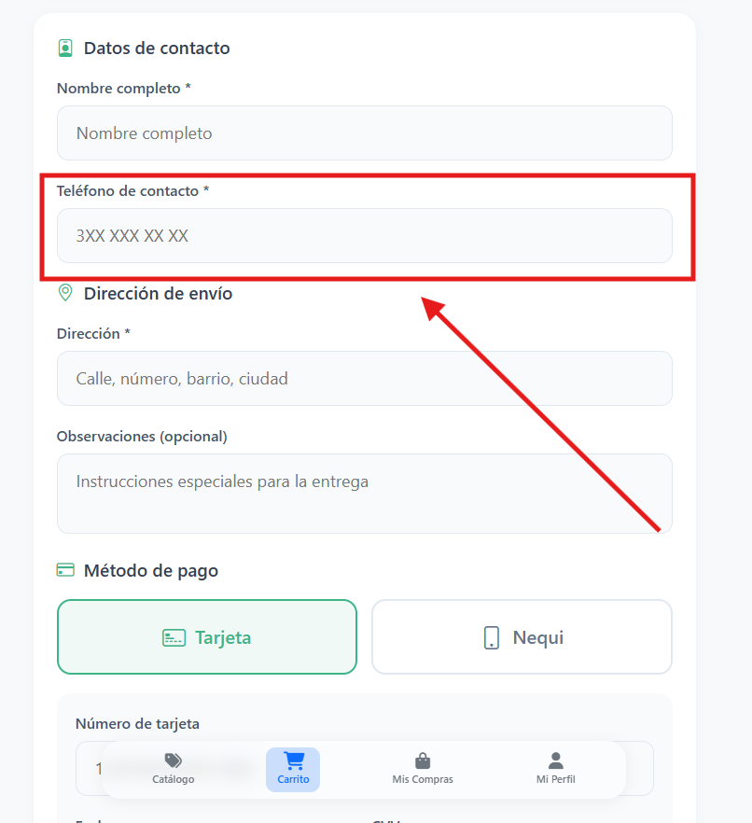

And the address (if we want it delivered to our home): 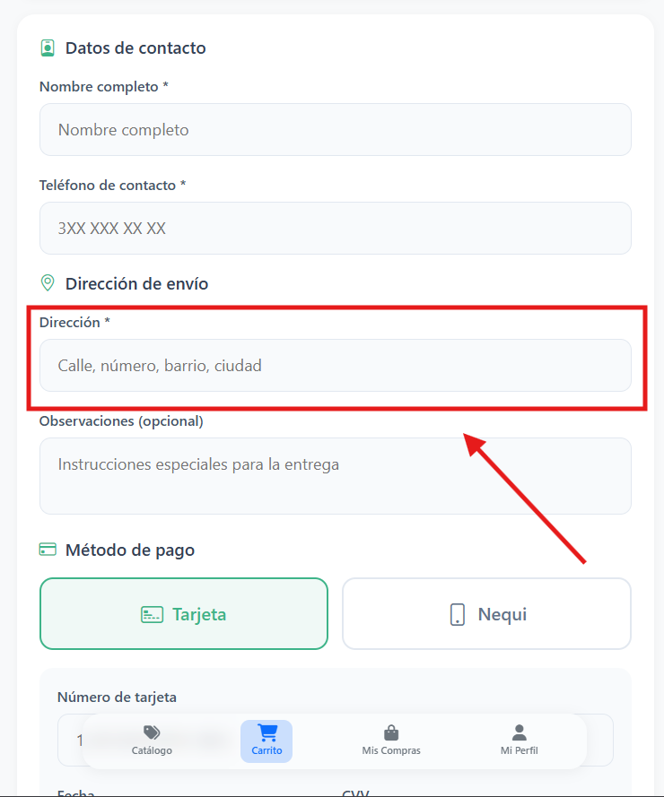

Then we will have the options of payment methods in which we can choose, pay by credit or debit card or pay using nequi: 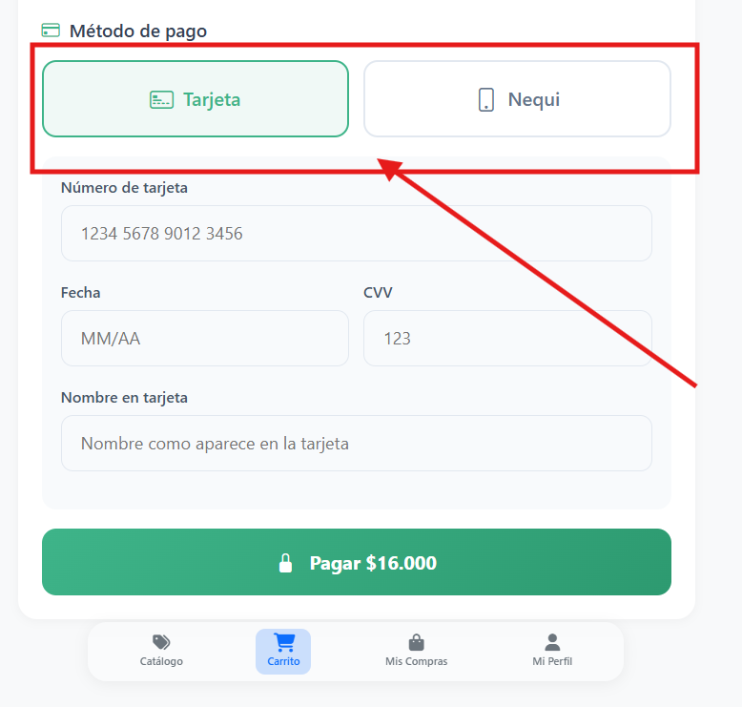

If we choose the card, we will be asked for the card number data 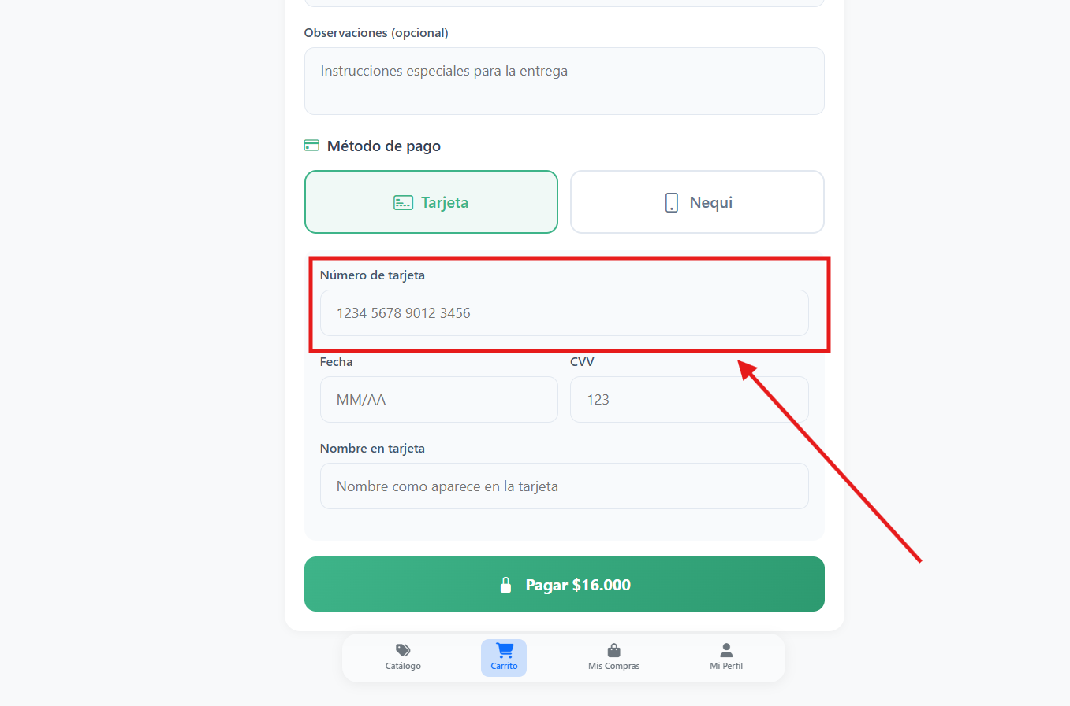
The date and CVV that we can find on the back of our physical card: 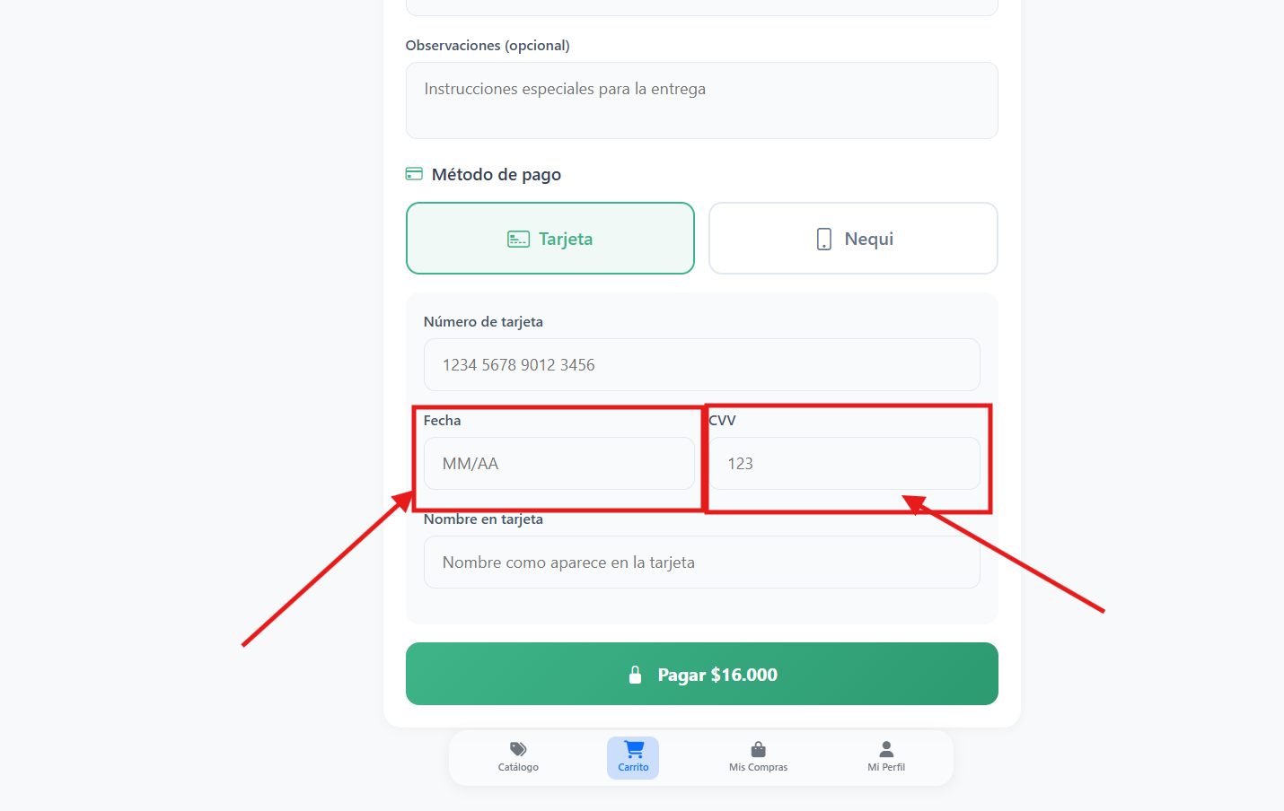
And the name of the card holder: 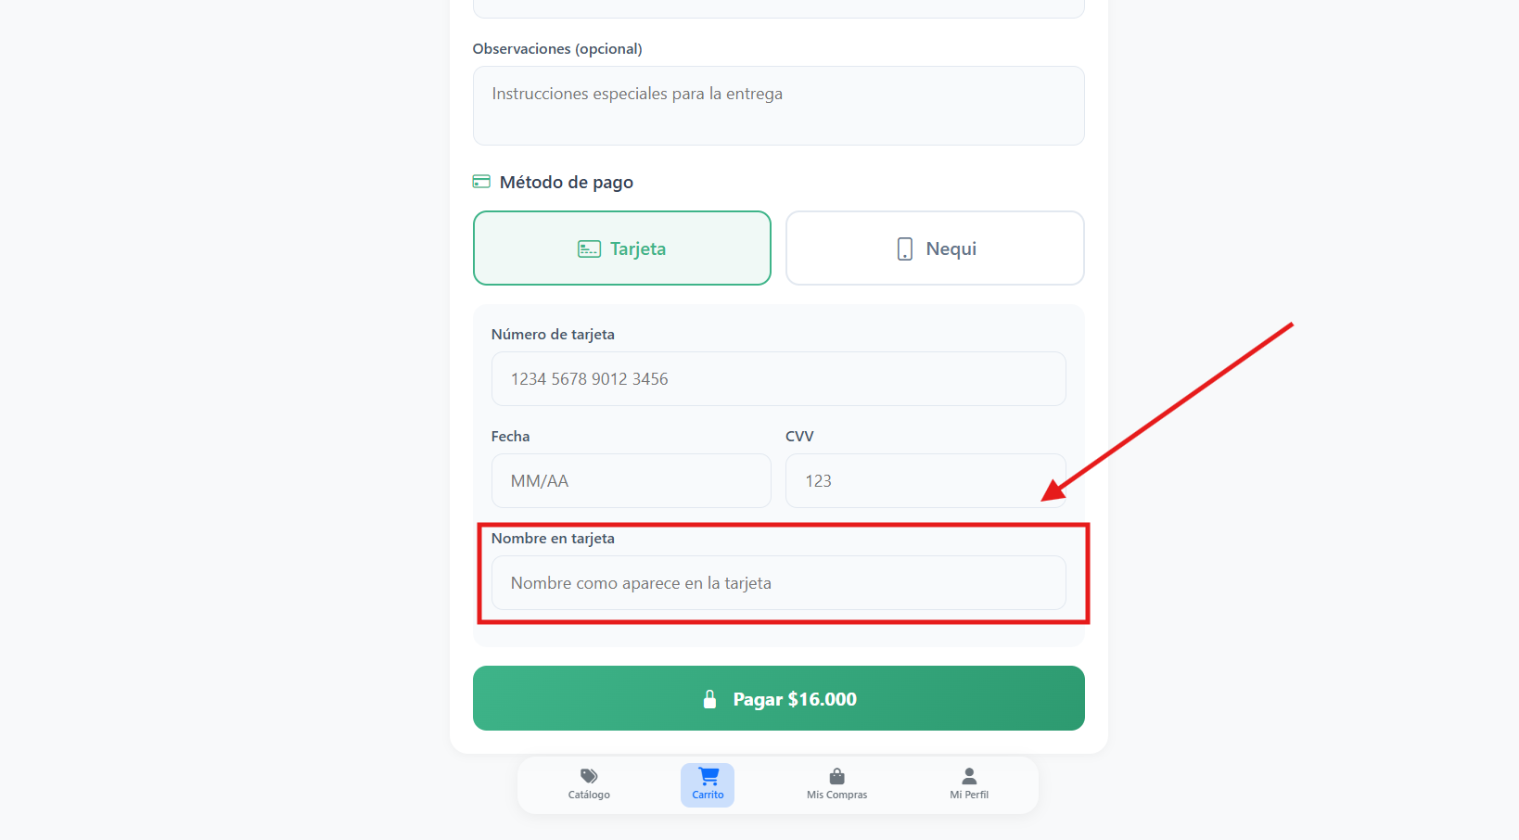

If, on the other hand, we select the payment method "Nequi", we will be asked for the account number: 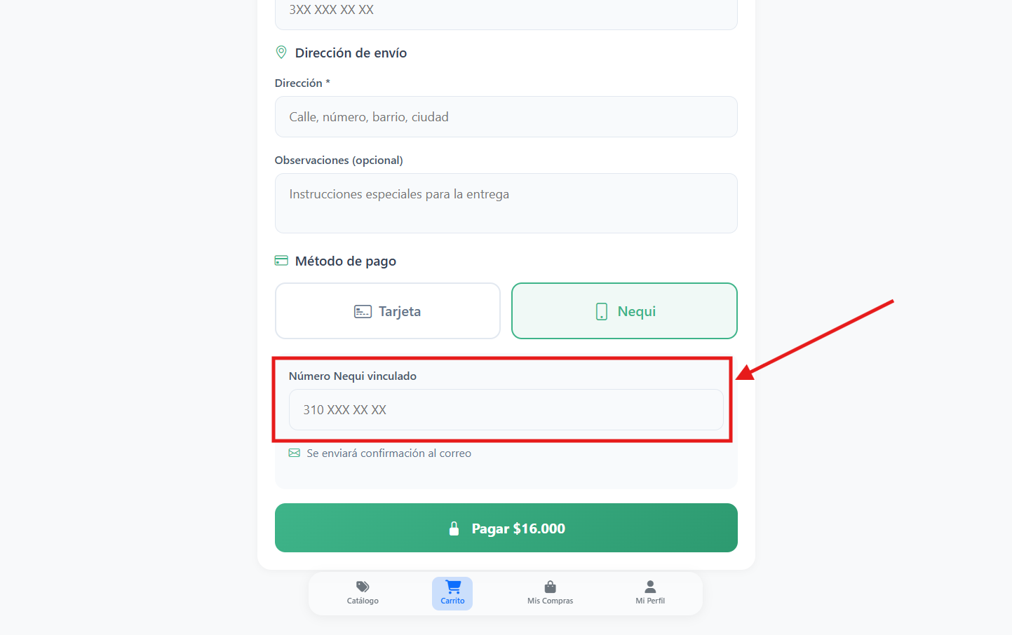
Once you have completed these data, you can proceed with the payment by pressing the "pay $ ##### button: 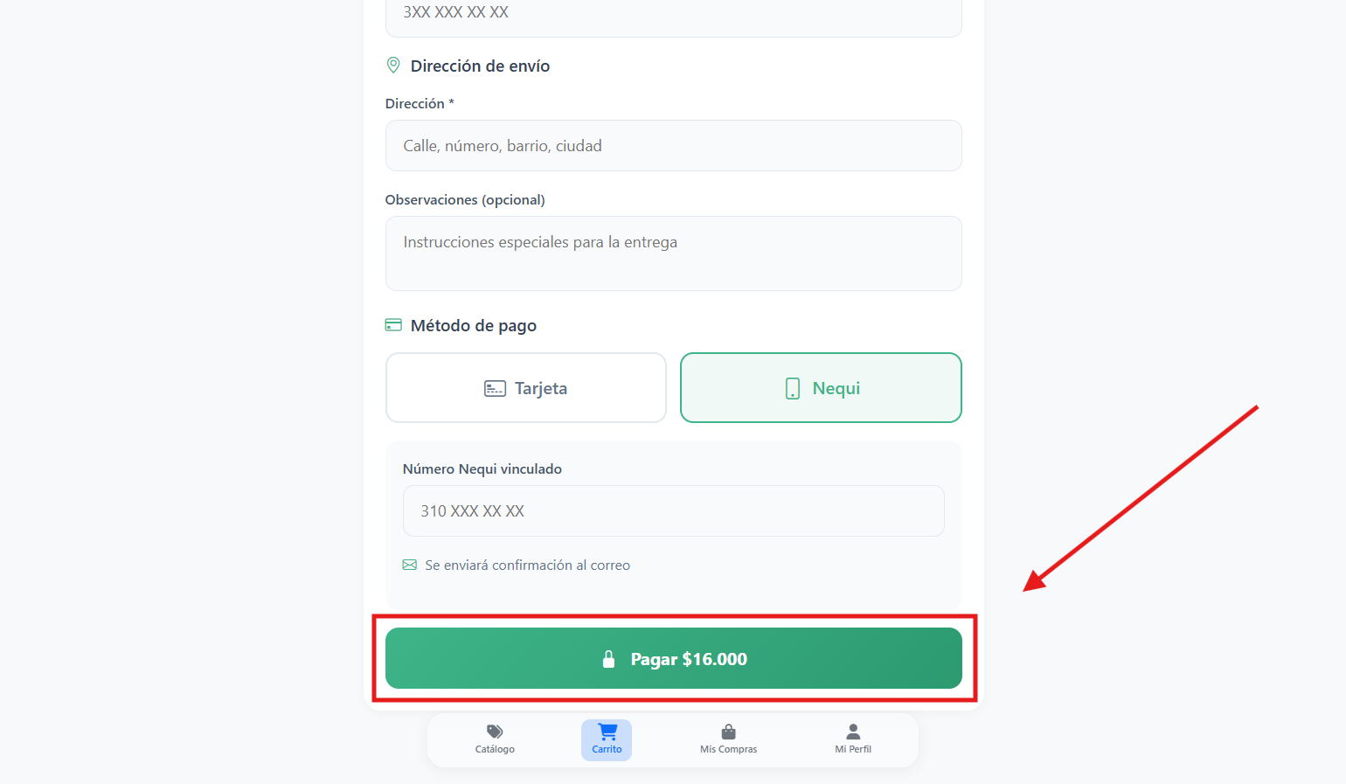

And it will be confirmed to us by sending us a confirmation email of the purchase in our email.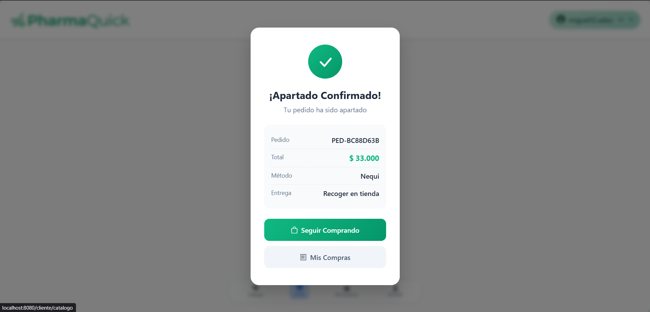
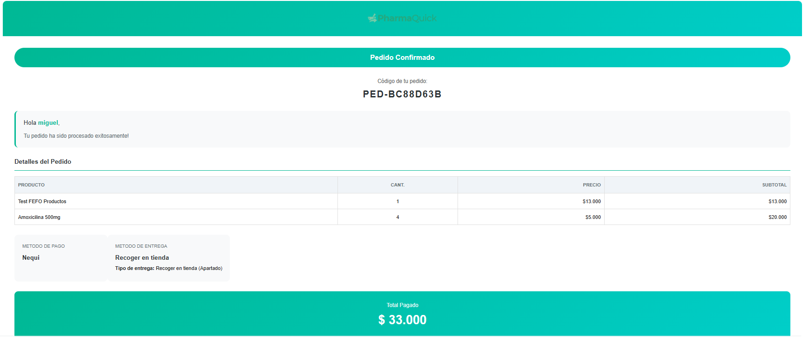

My purchases:

We can enter this section by pressing the "My Purchases" button in the bottom menu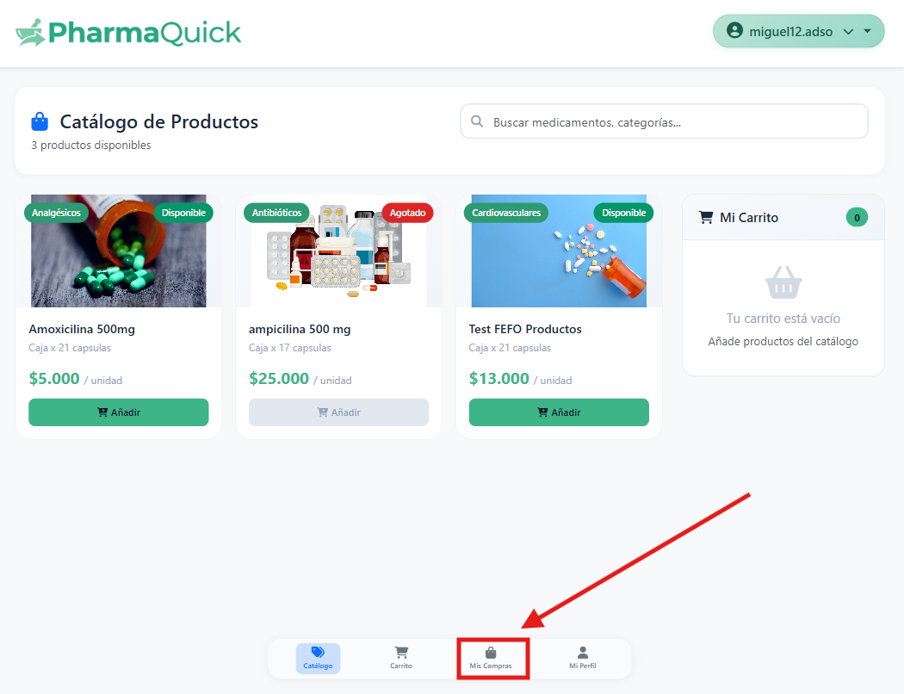

When we enter we will be able to see our purchases on the platform (if we have already made any): 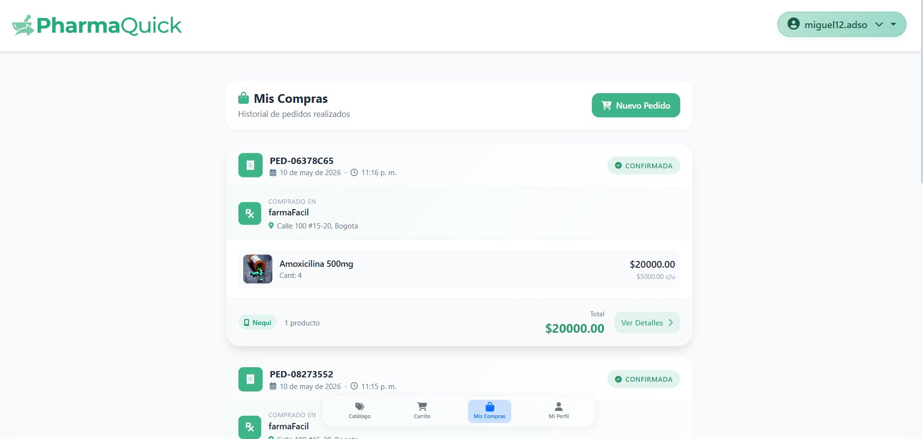

We will be able to see data such as the status of our order: 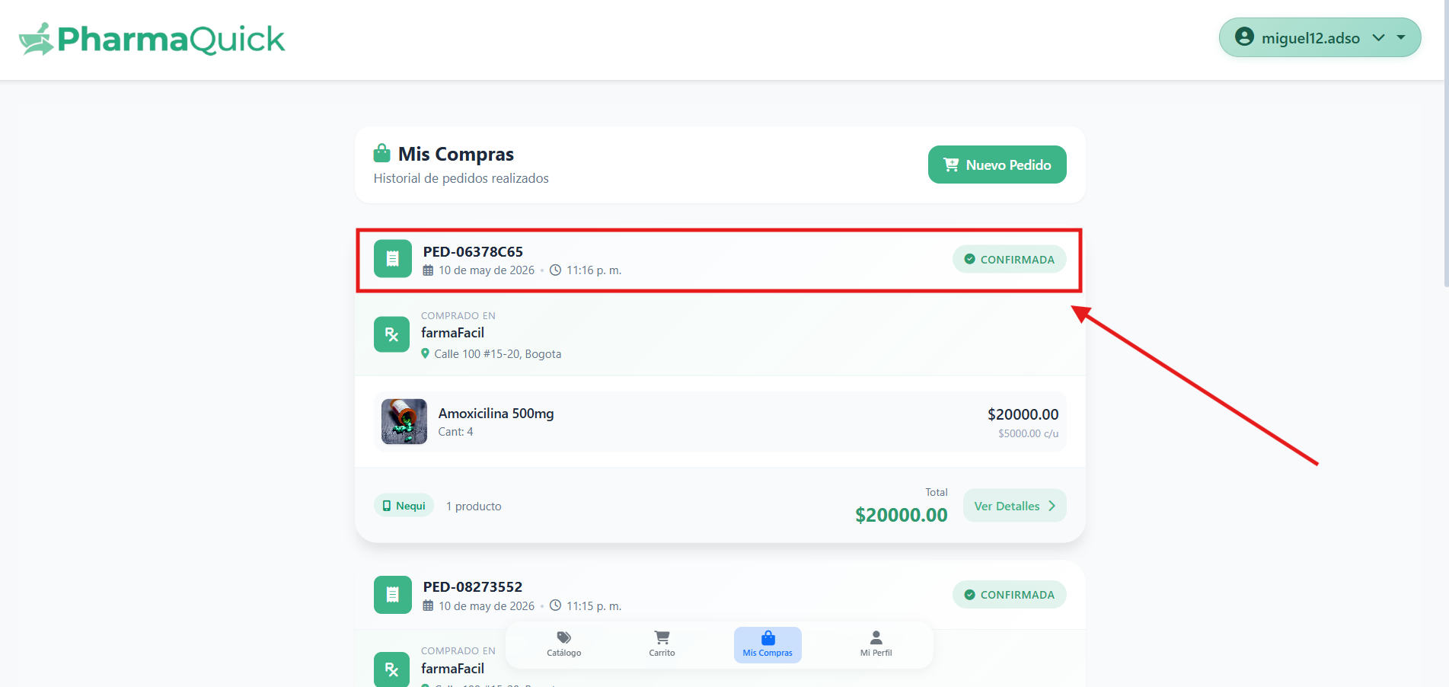
The name of the pharmacy where we buy the product and where it is located: 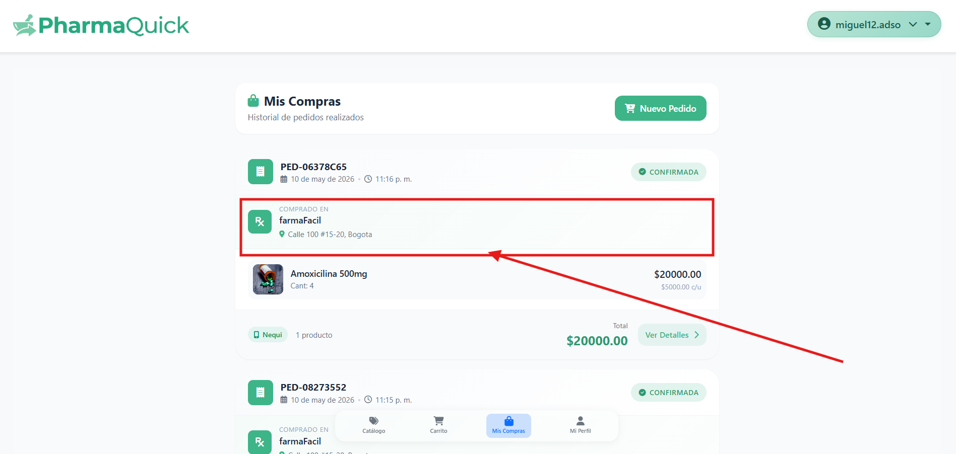

We will also be able to see the products purchased and other details: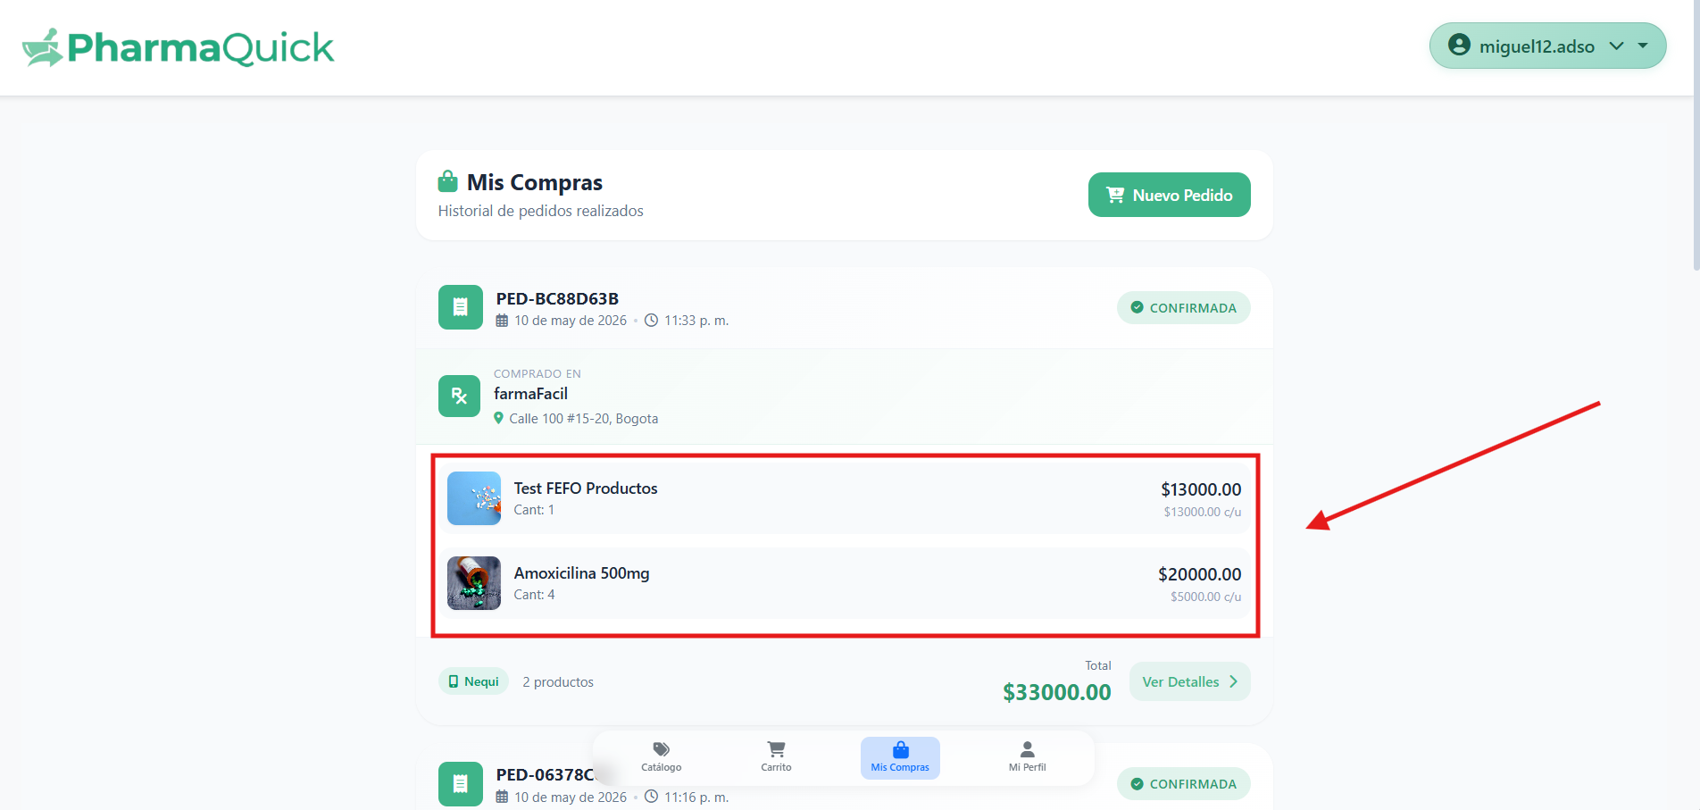

We will have the option to "see more details": 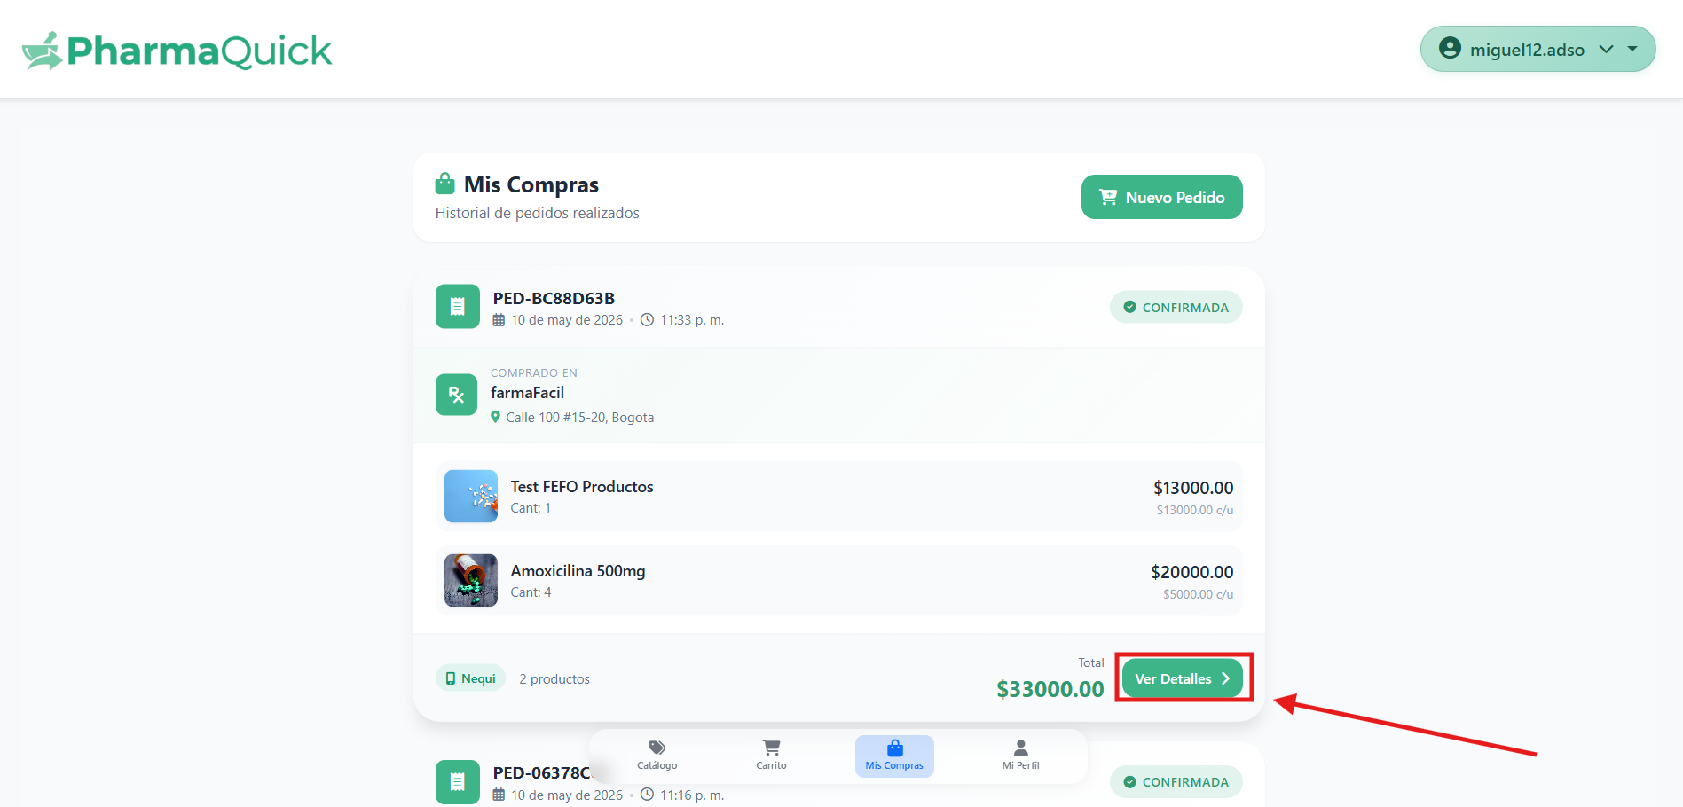

Which will let us see other details of the purchase and will not enable a button to talk to the whatsapp of the pharmacy where we made the purchase: 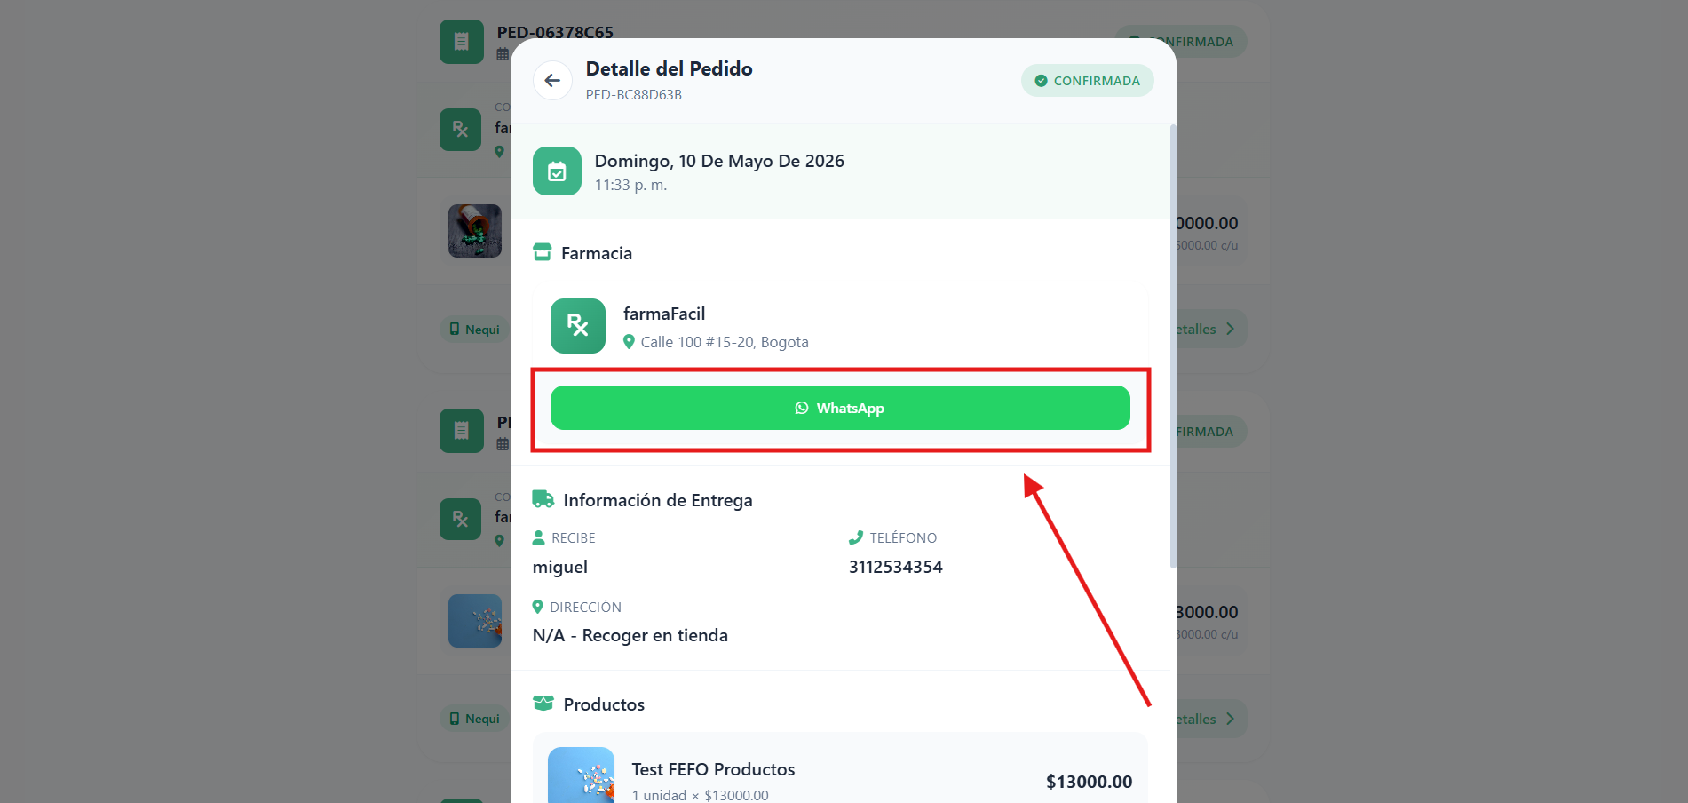

My profile
We enter this page from the bottom menu by pressing the "my profile" button: 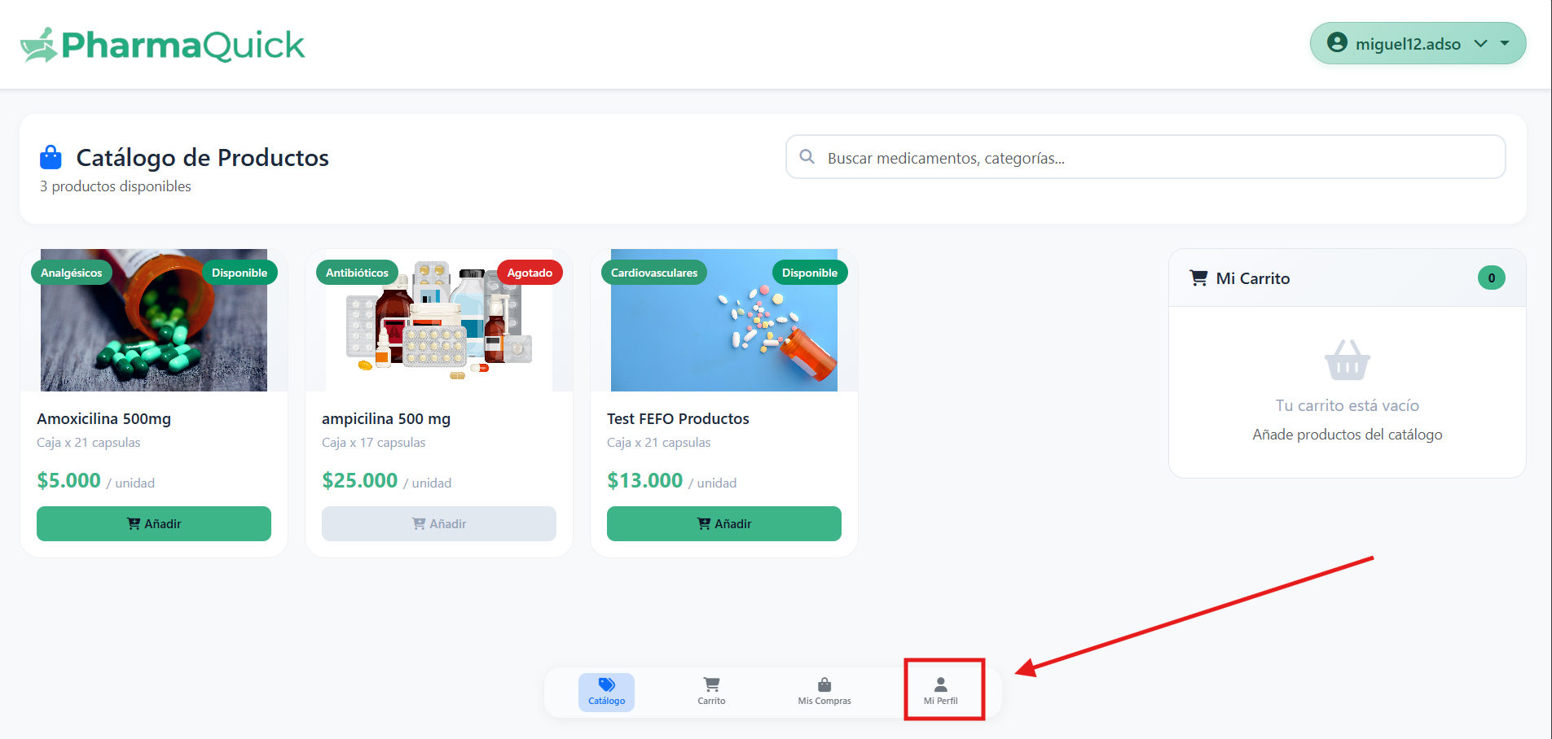

When you log in, you will be loaded with some of your data such as your email and your role: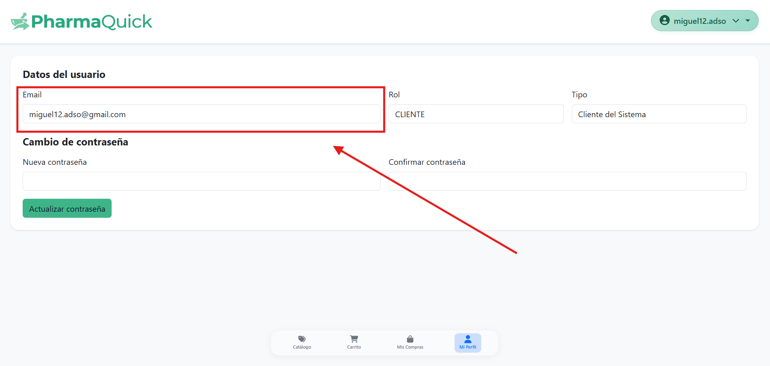
In addition, we can change our password if we wish: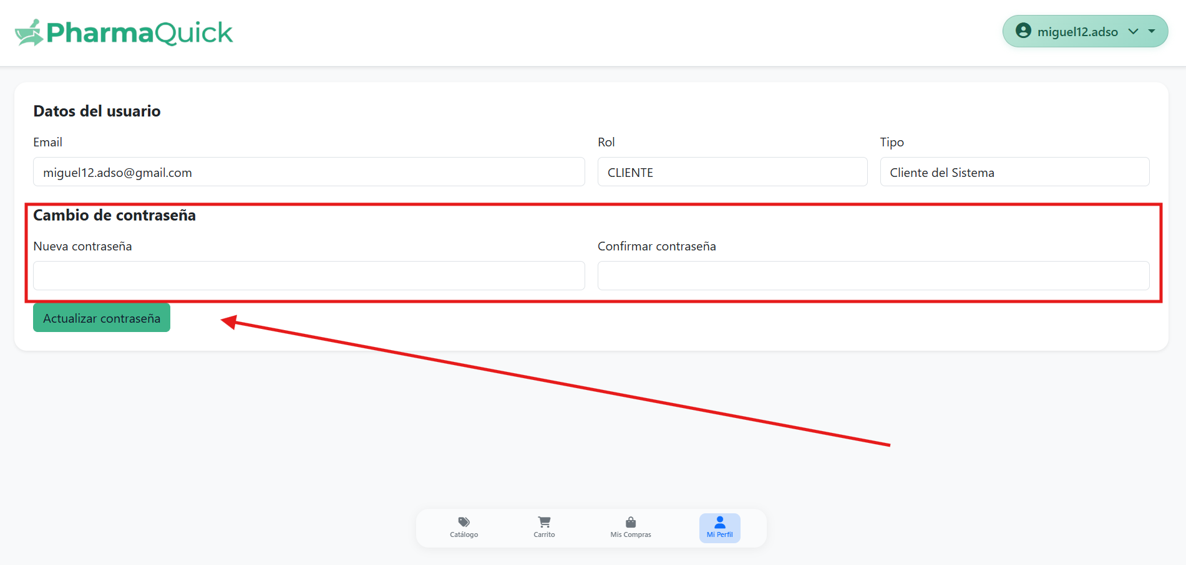

Log Out.

To log out of the application, press the upper right button: 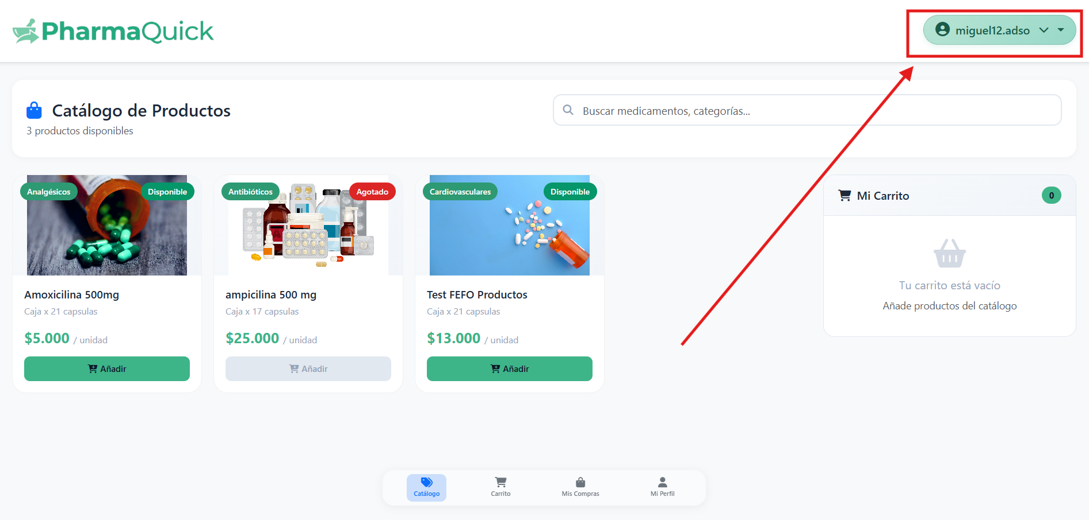
Doing so will enable the button to log out of the application: 